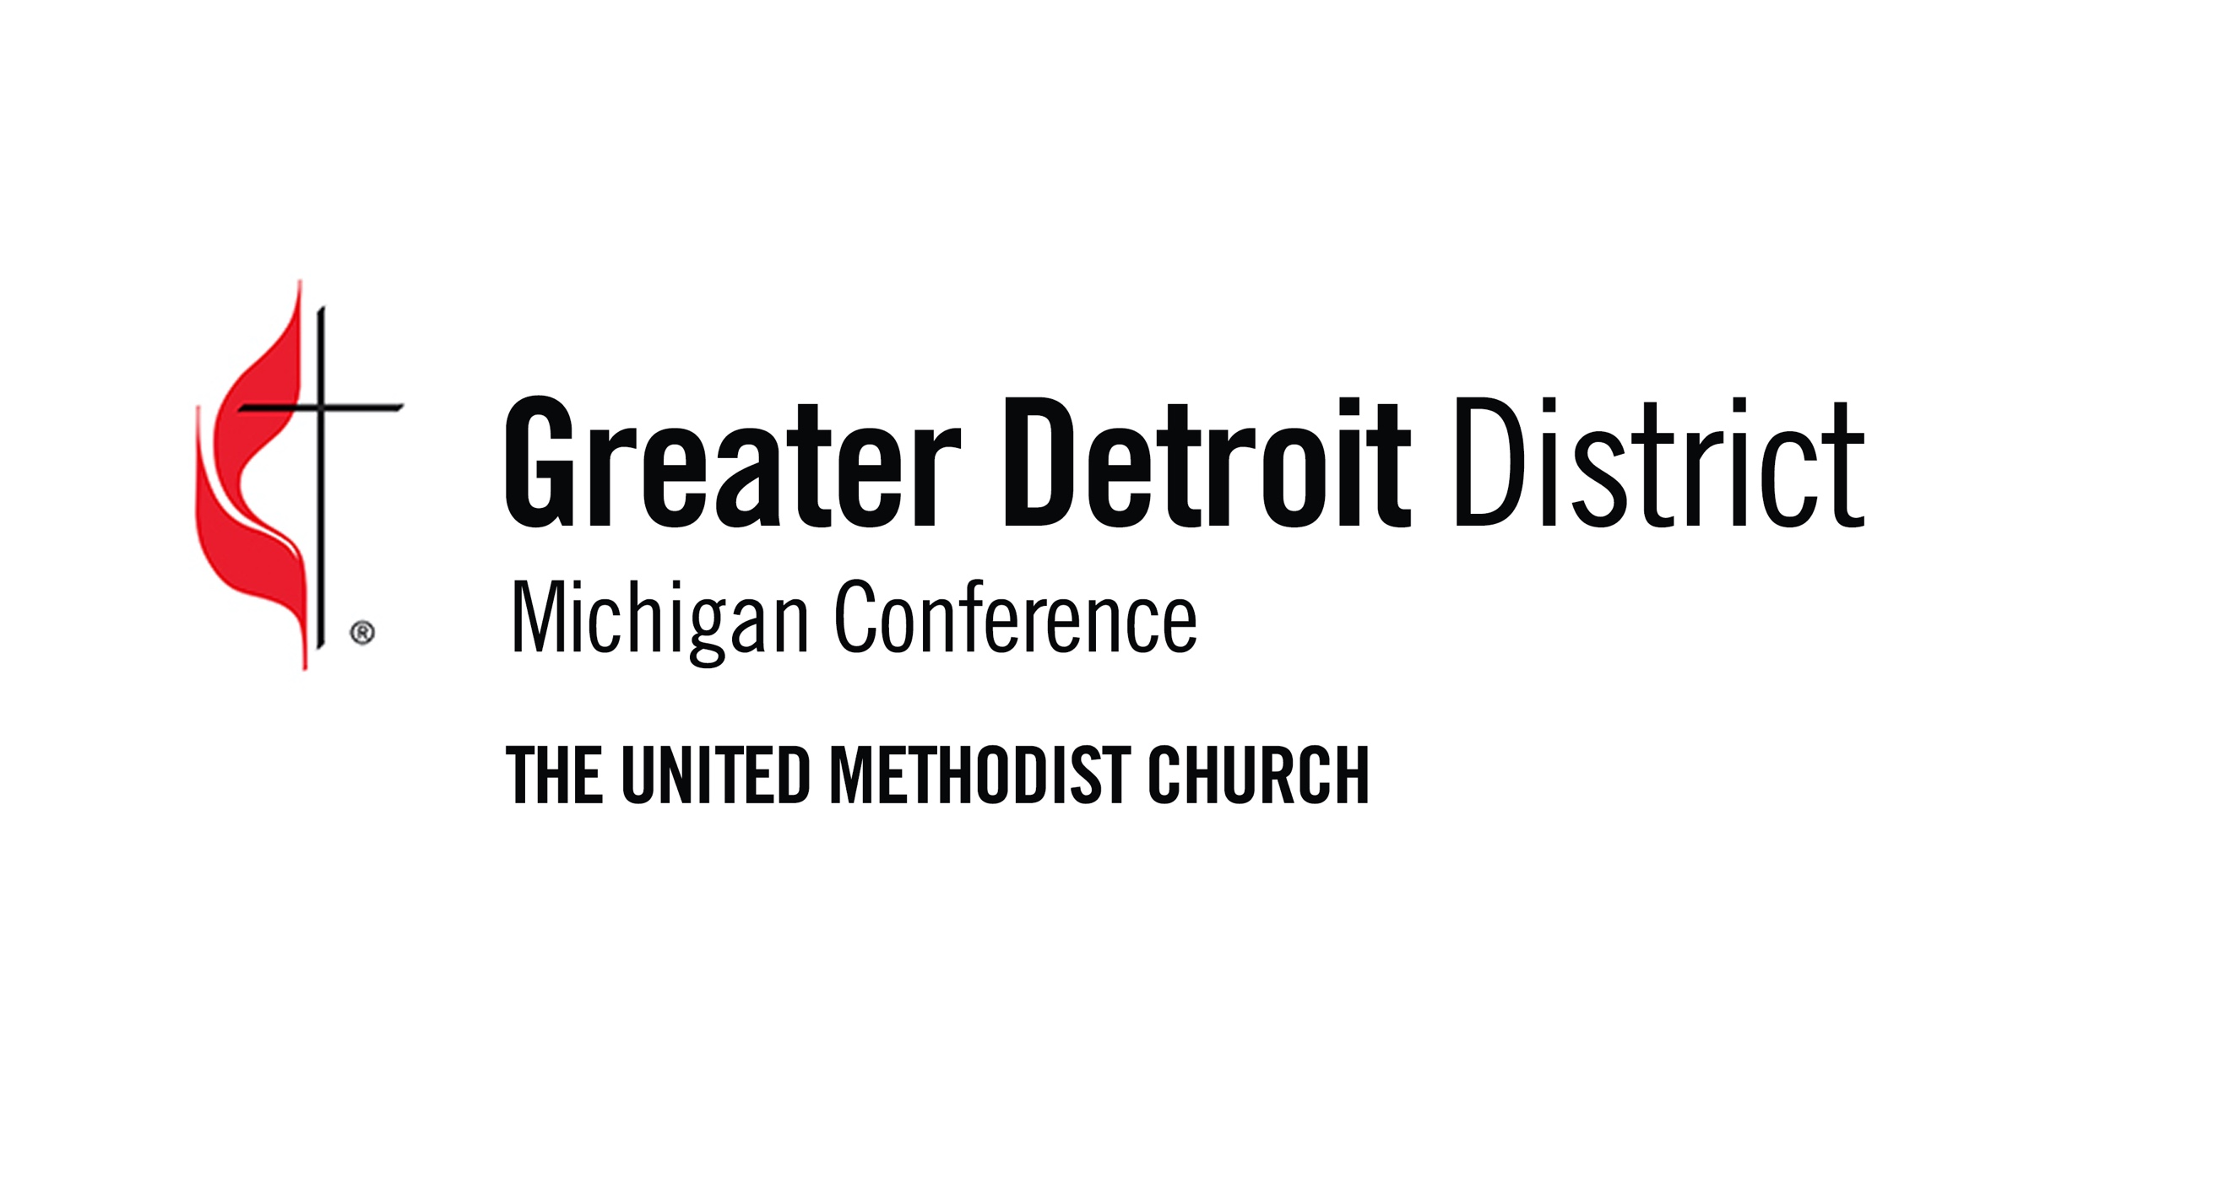
31st Celebration Honoring
Rev. Dr. Martin Luther King, Jr.
“Honoring the Journey”

Sunday, January 12, 2025
In person and Livestreamed • Grosse Pointe United Methodist Church
211 Moross Rd, Grosse Pointe Farms, MI 48236 • 313.886.2363
Rev. David Eardley, Lead Pastor

Dear Greater Detroit District Pastors, Lay Leaders, and Youth Leaders,

The Rev. Dr. Martin Luther King Jr. once said, “If you can’t fly then run, if you can’t run then walk, if you can’t walk then crawl, but whatever you do, you have to keep moving forward.” He spoke of the urgency of making progress--despite turmoil, despite animosity, despite setbacks. To pay tribute to his legacy, and to continue to cultivate his dreams within our own lives, we invite you to gather at the 31st Celebration honoring Dr. King.

Through a service of song, prayer, litany, and reflection, we will use our voices to honor the journey. We will present awards and scholarships to individuals within our congregations who are pivotal examples of his legacy and who use their lives as a platform to speak. This year we will also unveil a new award, The Beloved Community Grant. This celebration is always a beautiful way to recenter our hearts and intentions. It is uplifting, poignant, and powerful. We sincerely hope to see you there, either in person or via the livestream! To participate:

- Encourage your congregation to join us for this impacting service either in person or via livestream.

- Nominate a clergy or layperson who demonstrates Dr. King’s values to be named a “Drum Major for Justice.”
  - Please submit a one-page nomination by October 13, 2024 to the MLK Committee by email: MLK@greaterdetroitumc.org

- Reach out to high school seniors who are active members of your congregation and whose actions demonstrate a commitment to the values of Dr. King. Encourage them to apply electronically for a Scholarship for up to $1,000.
  - Please copy and distribute the enclosed Instruction and Application forms and remind them of the October 13, 2024 PDF email submission deadline (11:59 p.m. EST). Submissions must be sent to: MLK@greaterdetroitumc.org

- Donate to the scholarship fund by visiting this website or scanning this QR code:
  - https://secure.myvanco.com/L-Z9HV/campaign/C-1492T?access=tile_direct

Faithfully, your 31st Celebration Committee honoring Rev. Dr. Martin Luther King, Jr.,

Sherman Louis • Micki Phelps • Victor Raybaud • Tina Campbell • Rev. Jonathan Combs
Adrienne Trupiano-Stepaniak • Susanna Klimek • Rev. David Eardley, Host Pastor
SCHOLARSHIP INSTRUCTIONS

Michigan Annual Conference of the United Methodist Church, Greater Detroit District
Rev. Dr. Martin Luther King, Jr. Celebration Committee

“If you can’t fly then run, if you can’t run then walk, if you can’t walk then crawl, but whatever you do, you have to keep moving forward.” Dr. Martin Luther King, Jr.

Purpose of the Scholarship Fund
The Martin Luther King Jr. Memorial Scholarship Fund exists to honor Dr. King’s ministry and perpetuate his Christian values, particularly for the benefit of students and communities within the Greater Detroit District of the United Methodist Church. Scholarship recipients may be awarded up to $1,000 at the discretion of the Celebration Committee.

Application Packet Requirements (3)
- Submission of the Application Packet electronically (PDF) by current high school seniors within the Greater Detroit District.

- Submission of two (2) letters of recommendation: a letter from your pastor and a letter from another adult such as a leader in your church, teacher, or counselor. These should attest to your membership and participation in the United Methodist Church as well as your adherence to Dr. King’s values.

- Submission of an essay (typed, double-spaced, 12-point Times New Roman font, 500 words) using the theme: “Honoring the Journey” – Dr. King knew that the important things in life were worth fighting for. He urged us to remember that even though we may not be able to do it all, we can do some, and we can choose to keep fighting for change. Reflect on why it is important in our world today that we push the arm of justice forward, even despite the many obstacles present. Where do you witness the need to fly—or run—or walk—or crawl—in our society? How are you actively making a conscious choice to ignite change and move forward for the greater good?

Evaluation Criteria

- Evidence that the applicant understands Dr. King’s ministry and his Christian values.
- Examples of the applicant’s activities that implement Dr. King’s ministry, his dream, and/or stance on social justice.
- Writing that expresses how an applicant has been inspired by Dr. King and is likely to inspire others.

Submission & Deadline

Your electronic PDF Application, Letters of Recommendation, and Essay must be emailed on or before October 13, 2024 (11:59 pm EST) to MLK@greaterdetroitumc.org.

Or, complete the online application form and upload Letters of Recommendation, and Essay, here: https://forms.gle/DcLKFm7cQNzcbMW59

SCHOLARSHIP/GRANT APPLICATION FORM
Rev. Dr. Martin Luther King, Jr. Memorial Scholarship Fund
Michigan Annual Conference of the United Methodist Church, Greater Detroit District
Please download and fill out this application, then return it via email according to the instructions above. You may use additional pages as necessary.

Date:

Applicant’s Name:

Mailing Address: City/Zip:

Email:

High School:

Local Church:

Pastor’s Name: Pastor’s Contact:

List 2 or 3 church activities in which you currently participate to help make Disciples of Jesus Christ.

List 2 or 3 honors you have received as a result of your engagement in the community.

What 2 or 3 accomplishments are you most proud of?

- Include your Essay as an attachment.
- Include 2 letters of recommendation: One from your pastor and the second from another adult (such as a Lay Leader in your church, teacher, mentor, or counselor)

